President Biden calls for largest-ever VA budget, boosting veteran medical care by 20%

A White House proposal released Monday would push the VA budget to more than $300 billion for the first time, with much of the increase going toward veterans’ medical care.
Overall, the proposal amounts to a 10.5% increase over the VA’s enacted budget for 2022. The White House is requesting about 20% more for medical care, and it cited health care inflation, as well as the lasting effects of the coronavirus pandemic, as major reasons for the boost.
The VA uses modeling similar to what’s used by insurance companies to estimate demands for health care. Based on the agency’s projections, veterans will rely more on the VA for their medical care in 2023, said Laura Duke, chief financial officer of the Veterans Health Administration.
The blueprint will be debated and negotiated by Congress, which is responsible for approving federal budgets. While Congress doesn’t typically approve presidential budgets as proposed, lawmakers have historically given the VA more money than presidents have requested for the department.
Read more in Stars & Stripes.

Veterans on managing anger
When Gus served as a U.S. Army infantryman, he found that anger was not only accepted but could be channeled in ways that could make for a better soldier. But after transitioning out of the military, he realized his anger was coming out in “real unhealthy ways.”
“I didn’t have my emotions under control, I didn’t have my anger under control, and it was damaging — not only to other people but to myself,” Gus says. “I didn’t want to live like that.”
After transitioning out of military service, many veterans like Gus have a tough time reining in their anger, and it can start spilling into ordinary situations.
Because everyone experiences some degree of anger, from being mildly annoyed to feeling intense rage, it’s not always easy to know if or when to seek professional help. You may consider taking an online self-assessment or exploring self-help programs like AIMS, VA’s Anger and Irritability Management Skills course for veterans and service members.
But if anger is affecting your work, relationships or activities, or if you’re feeling short-tempered or frustrated more often than you usually do, speak with your provider. Anger that disrupts your life may point to an underlying mental health issue that needs to be addressed, such as depression, anxiety disorder or PTSD. Frequent or prolonged anger and irritability can contribute to high blood pressure, headaches and ulcers.
Read more on VA's Make the Connection website.

Single sign-in eases veteran access to VA websites
It’s now easier for veterans to log in to access VA benefits and services with the expansion of the unified sign-in experience.
My HealtheVet is joining VA.gov and My VA Health in offering a consistent sign-in experience, which also adds a layer of security. (My VA Health is only for veterans in Spokane and other sites where the new electronic health record system has already been deployed.)
The single login page looks and feels the same no matter which VA website you choose as a starting point. When you log in, you’ll be able to move between VA websites seamlessly rather than logging in at each stop or remembering multiple usernames and passwords.
If you’ve already created an online VA.gov account, congratulations – you’re good to go! If you don’t have an account, it’s easy to get started.
Learn more at the VA's VAntage Point blog.

Resources to help veterans find a job
Many resources are available for veterans who are transitioning back into civilian life, including opportunities to find work similar to your military career, or training to change directions completely. Find local opportunities to connect with employers looking to hire skilled workers like you.
Visit this Michigan Works! veterans page or Michigan Veterans' Employment Services to learn more.

Need to locate your DD 214? Connect to VA benefits? Get emergency assistance? Lean on us at the MVAA
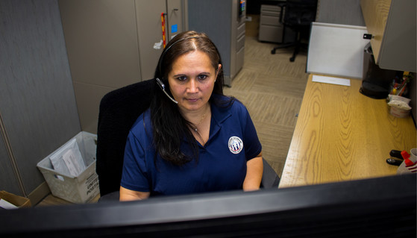
The technicians in our Michigan Veteran Resource Service Center (MVRSC) work with hundreds of veterans and dependents every week -- and stand ready to help you with your needs at 1-800-MICH-VET (1-800-642-4838).
They can help you locate your DD Form 214 discharge papers. Or connect you to a certified Veteran Service Officer who can help you file a claim for VA disability benefits. Or guide you to the right spot to apply for emergency assistance.
The MVRSC is staffed by technicians from 6 a.m. to 5 p.m. Monday through Friday. Trained agents from Michigan 211 take over after hours, ensuring someone is there to answer calls to 1-800-MICH-VET 24 hours a day, 7 days a week.
Or you can use our Check on MIVet form by visiting michigan.gov/MVAA and clicking CHECK ON MIVET. Fill out and submit the form and we will contact you and connect you to the needed resources -- from health care to employment to education assistance. As a state agency, all of our services are complimentary and confidential.
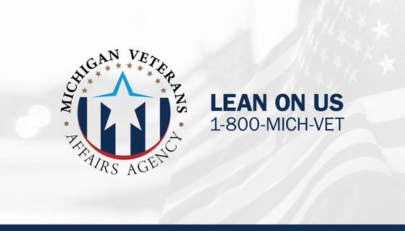

What veterans need to know about military discharge upgrades
You have spent countless years of your life serving your country with honor and distinction, only to find yourself facing a discharge less than fully honorable due to misconduct. Your retirement could be lost, the education benefits you earned are now gone and your entitlement to other VA benefits has been stripped away as well.
The various discharge review boards provide a mechanism to restore your entitlement to those veterans benefits in the form of a discharge upgrade. While the name of the board seems self-explanatory and the process appears straight-forward, it can be very complicated for some, according to a column in Military Times by attorney and Marine veteran Eric Duncan.
The review boards exist for all branches of the military and have the power to correct inequities or improprieties in military service records. This can mean upgrading a discharge from other than honorable to general under honorable conditions and can result in the restoration of some veterans’ benefits administered by the VA. An upgrade from general to honorable would restore a veteran’s access to Post 9/11 GI Bill education benefits and allow the service member to take advantage of educational opportunities following service while avoiding the ever-inflating cost of an education.
Besides upgrading a military discharge classification, the boards possess the power to change a veteran’s reentry code, correct the narrative reason for separation, and even change the separation authority. This could result in a veteran becoming eligible to reenlist in the military or avoiding having to explain why their DD-214 lists things like “drug abuse” or “serious misconduct” under the narrative for separation.
A veteran has the right to submit a request to the discharge review board so long as the application is made within 15 years from the date of his or her separation from service.
Read the rest of Duncan's column in Military Times.

